**Platform dependent and independent languages**

Platform means the type operating system (OS) of your current computer.

OS is **system** software that manages **computer** hardware, software resources, and provides common services for **computer** programs.

There are several types of OS as shown in this picture:

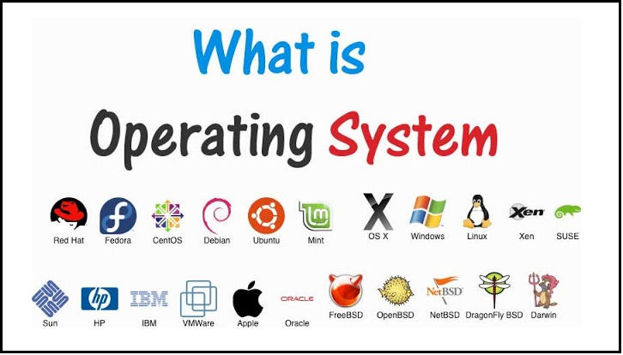

**Platform dependent language:**

There are a programming languages running in a specific OS and doesn’t running directly on another (Must be compiled first).

Platform depending languages like: C++, C#, C

Example:

If you built specific software programmer on Linux OS using C++ programming language and after finishing you want to run the same project but this time on a windows OS. The result is the program doesn’t run.

**Platform Independent (cross-platform) languages:**

There are a programming languages running in all OS (don’t need to be compiled).

Platform independent languages like: PHP and JavaScript.

Example:

If you built specific software programmer on Linux OS using JavaScript programming language and after finishing you want to run the same project but this time on a windows OS. The result is the program runs.